Table of Contents
Introduction 3
Word Limit: 3
Learning outcomes to be assessed: 3
1. Critically evaluate the basic concepts of network scaling technologies including design principles, LAN redundancy and Link Aggregation and how they are used. 3
2. Analyse and assess the suitability of relevant LAN/WAN protocols/technologies and virtual infrastructures within a modern communication infrastructure. 3
3. Evaluate the requirements for complex IT infrastructures, demonstrate its design and configuration utilizing routers and switches within a single and multi-area domain. 3
4. Critically assess the relative merits of a range of potential solutions for a complex application. 3
Assessment Description 3
The Deliverables 7
Presentation and Referencing (10%) 7
What to submit and where? 8

Introduction
This document provides all the information necessary for you to complete the assessment for the Advanced Network Solutions module. The marking scheme is provided in a separate document (010_MOD006123_Marking_Scheme.docx), please check it to understand the full breakdown of the marks for this assignment.

Word Limit:
Your report should be approximately 3000 words in length, excluding tables, diagrams (including associated legends), appendices, reference lists, tables of contents, footnotes and endnotes.

Learning outcomes to be assessed:
- Critically evaluate the basic concepts of network scaling technologies including design principles, LAN redundancy and Link Aggregation and how they are used.
- Analyse and assess the suitability of relevant LAN/WAN protocols/technologies and virtual infrastructures within a modern communication infrastructure.
- Evaluate the requirements for complex IT infrastructures, demonstrate its design and configuration utilizing routers and switches within a single and multi-area domain.
- Critically assess the relative merits of a range of potential solutions for a complex application.

Assessment Description
Cambridge Cybersecurity Consultants (CCC) is a cybersecurity company that has expanded from Cambridge to London and Manchester over the past 5 years. The company currently runs an old network shown in Figure 1, which seems to go down very often, affecting their profit margins and company business reputation. The chief financial officer (CFO) has set aside a sizable budget to design, justify and create a new network for the company to solve the network resilience problem. This network in Figure 1 currently only allows a few personal computers (PCs) per site, but with your help, this is to be scaled up to a significantly larger size which takes into account the following requirement specifications which you must adhere to.
The 3 company sites shown in the topology below in Figure 1 must be included in the new network design and in addition, there has to be 1 connection to allow access to the Internet from the Cambridge site. However, only internally initiated connections from the company’s intranet are permitted to access the Internet. The IP WAN address from the Cambridge site to the ISP is 209.165.200.224/30 All the IP addresses for the 3 sites must be obtained from the initial network address of 172.16.0.0/16 That means you must use variable length subnet masking (VLSM) to derive your IP addresses for the 3 sites i.e., Cambridge, London and Manchester, as well as the wide area network (WAN) link addresses. Below are the specification requirements for the number of hosts that must be supported per site and all the LAN connections must be at least 100Mbps links (fast Ethernet) or 1000Mbps links (Gigabit Ethernet):
- 300 hosts on the Cambridge site;
- 1200 hosts on the London site;
- 2100 hosts on the Manchester site;
Your task is to subnet the IP address 172.16.0.0/16 to address 6 subnets in your new network topology design, which includes the Manchester to London WAN, that will support the required number of hosts. You are NOT allowed to use subnet calculators and all your work on how you derive the IP addressing table must be shown in your report. An addressing table for the new network design must be included in the finished report.
All 3 sites must be secured with passwords (i.e., privilege EXEC mode passwords, console passwords, VTY passwords and only allow safe connection methods, i.e., Telnet connections should be disabled and only SSH connections should be allowed on the VTY lines on each site. All 3 sites must also have basic switch and router configurations such as assigning device names to the switches and routers, encrypting the plaintext passwords, creating banners, setting the clock on the switches and routers and saving the running config to non-volatile RAM. Appropriate port security should be applied to all non-trunk based switch ports.

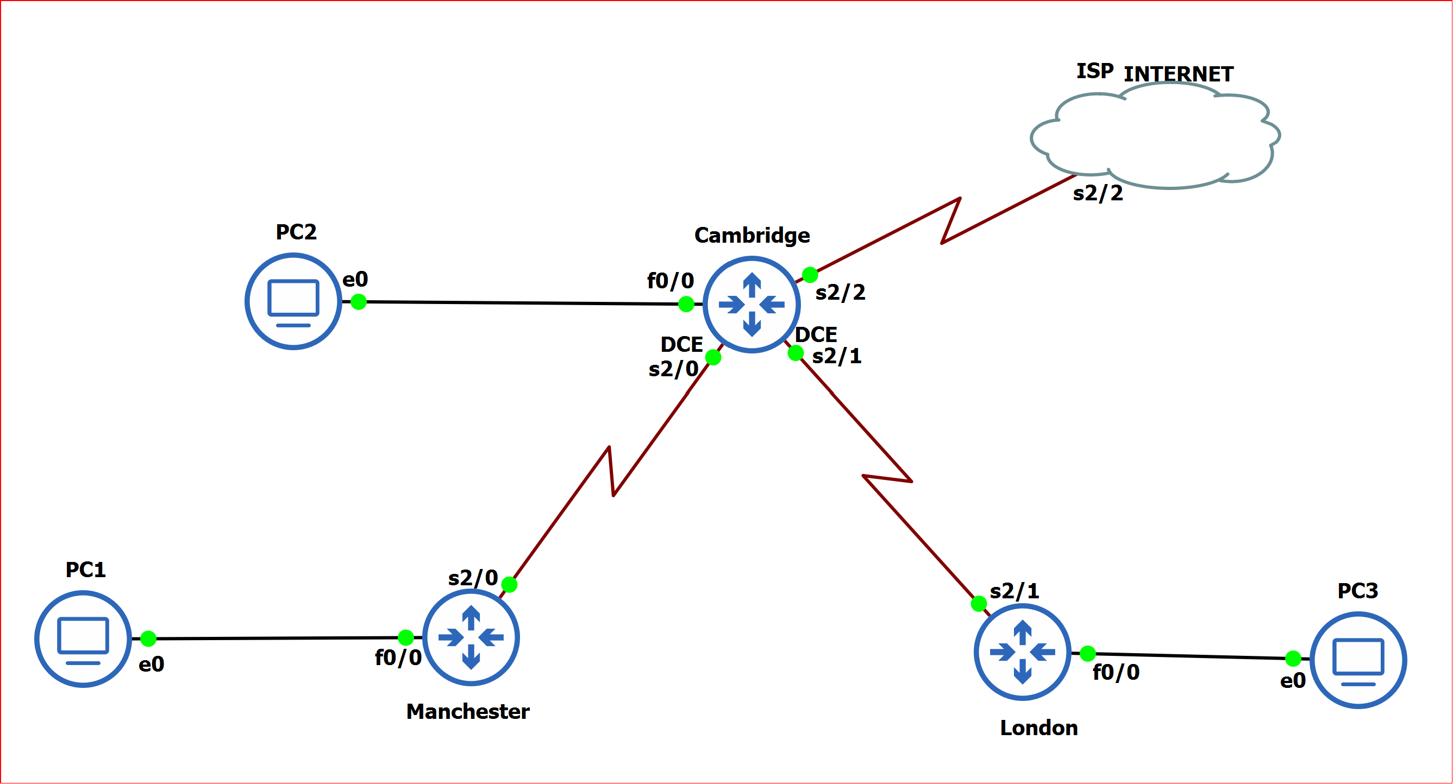
Figure 1: Original Customer Network

The company has also heard that switches are great for scaling and segmenting network traffic and they would like you to use switches in your network design. They are also very keen to adopt Cisco equipment as they hold Cisco in very high regard and for this reason, CCC would like the new network to use Cisco ISR4331 routers and Cisco catalyst 2960 switches for the 3 sites. Redundancy should also be considered in your design. For example, if the London to Cambridge WAN link goes down, the London site should still be able to communicate with the Manchester and Cambridge sites. All 3 sites must have the following 3 VLANs:
- VLAN 10 named “Sales”
- VLAN 20 named “HR”
- VLAN 99 named “Management”
The choice of how you wish to segment the layer two networks is for you to decide and justify. In addition, for each site, you should implement an EtherChannel with 4x100Mbps links aggregated together between the Sales and HR VLANs as shown in Figure 2 below.
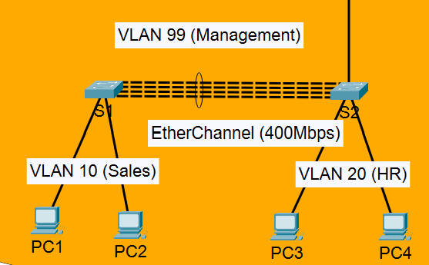
Figure 2: EtherChannel aggregated link between VLAN10(Sales) and VLAN 20 (HR)

Each site must have a routing protocol that is fully configured and working and as CCC prefer to use Cisco equipment, you should use EIGRP routing protocol with autonomous system 100 (AS100) for all 3 sites. You must also justify why EIGRP is the best option for the new CCC network design in comparison to other interior routing protocols such as RIP and OSPF. In addition, due to the previous problems of services going down, the company wants a method for the network to function, even if the dynamic routing protocols fail. In other words, you have to factor into your design, how the network can continue to function in the event of the dynamic routing protocols failing. (Hint: How else is traffic forwarded in a computer network in the absence of dynamic routing protocols? Floating static routes.)

The bandwidth of all WAN links must be set to 4000000 bps and the clock rate of the DCE ends must be set to 4000 Kbps. The Cambridge site must have a connection to the Internet/ISP which is propagated to the rest of the company’s network. However, due to the sensitive work undertaken at the Manchester branch, they are NOT allowed to access the Internet at any time, under any circumstances. You therefore need to factor in security measures (ACLs) to block traffic from the Manchester site reaching the Internet. The company would also like each user's end device to receive and have an IP address configured dynamically or automatically (DHCP) without user intervention.
The network topology in Figure 1 above is the current network topology of what CCC has and your task is to redesign and implement an improved network topology design which adheres to the requirements specifications stipulated above.

The Deliverables
The company wants an improved network topology based on the given requirements, delivered to them in a technical report that breaks down each technology used and what problems it solves. This is to be accompanied with concrete verification/evidence that the network design meets the requirements specifications and that it is fully operational before they buy the required equipment and implement the new network on the respective sites. Therefore, your report needs to have an executive summary, an introduction, a design section which includes subheadings such as VLSM addressing, scalability and resilience, dynamic routing and floating static routes, security and remote access, access control lists, network address translation (NAT), EtherChannel, Inter-VLAN routing and DHCP. You also need to have a test plan/strategy section, a results section, discussion/summary section and a conclusion. It is recommended for ease of marking and clarity of your report, to have the results section/evidence of testing at the end of each subheading, where appropriate. However, the final decision on how you layout your report is at your own discretion. The specifics are shown in the marking scheme available on Canvas (010_MOD006123_Marking_Scheme.docx) and you are encouraged to use the suggested subheadings to make mark allocation fair and consistent.

Presentation and Referencing (10%)
Please note that the quality of your report will also have a 10% weighting of the final mark for this assessment element. In this criterion, we will be looking at the language used (it must be the correct academic language, i.e., English); how the report is structured; your grammar and spelling; correct usage of the Harvard Referencing style; etc. It is import to have credible references from published books, peer reviewed research papers, journals, conference proceedings, etc., and not solely on web site articles. For detailed information on this, please refer to the Academic Writing Step by Step guide provided by Study Skills Plus.
When writing an academic report, you should not write in the first person, but rather, in the third person. Writing in the first person means writing from the author's point of view or perspective and this point of view is used for autobiographical writing as well as narrative, but not academic reports. The first person is an alternative to second person, which uses "you," as in the sentence "You are the smartest person in the room." Third person writing means that the writer of the report i.e. you, must avoid using subjective pronouns such as “I” or “you.” and it makes your writing more objective and less personal. For academic writing, this sense of objectivity allows you, the writer, to seem less biased and therefore, more credible; focusing your writing style on facts and evidence instead of personal opinion. For example instead of saying: “In this report, I/we will be discussing”, you could say: “This report discusses”.

The university has updated the guidance to students on the use of artificial intelligence (AI) for Assessment and Learning which can be found at this URL: AI Tools at University: Introduction. It details permissible and non-permissible use of AI tools in the preparation of coursework assignments such as this one, as well as correct referencing and plagiarism of AI-generated content, critical thinking and AI, as well as ARU regulations. In particular, please note the guidance on what is NOT allowed.

Reports with high Turnitin Originality scores will be carefully scrutinised and if necessary, will be sent to the Director of Studies for further investigation as possible academic misconduct. The penalties for plagiarism can be extremely severe and you are strongly advised not to plagiarise someone else’s work.

To understand how your final mark will be calculated as well as the weight of each of the elements described here please refer to the Marking Scheme of the assessment element available on Canvas (010_MOD006123_Marking_Scheme.docx) and also on the rubric on canvas at the bottom of the assessment brief page.

What to submit and where?
As part of your final submission, you must submit:
ONE 3000 word document/report and the name of the document/report must be your SID number with 7 digits, e.g., 1234567.docx to be submitted via Canvas and containing the following:
- A cover page that includes your SID number (NOT YOUR NAME) as these will be anonymously marked, the module code and the module name.
- The design, implementation, testing and verification of the new network topology in line with the requirements specification given above.
- A list of references in line with ARU’s Harvard Referencing standard.
The 2nd file must be your completed and fully configured Cisco Packet Tracer file and the name of the file must be your student ID (SID) number in 7 digits, e.g., 1234567.pkt. Again, you must not include your student name as this assignment will be marked anonymously.
The submission of the file must be done via Canvas by the dates indicated in e:Vision.

